Discuss the dataset
Introduction
There are two dataset types provided; train_revised.csv (as a training dataset) and test_question.csv (as a testing dataset) datasets.
The train_revised.csv contains dataset of tickets purchased from Mobiticket for fourteen (14) routes from “up country” into the city of Nairobi. The dataset runs for a period between 17 October 2017 and 20 April 2018.

Training dataset (train_revised.csv)
The train or training data is data for building a model, it’s used in a supervised learning as it contains outcomes to train the machine/model. The variables and sample data for this dataset are as shown in the figure 1.1.
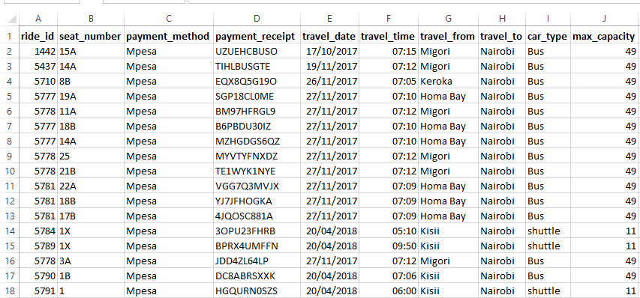
Figure 1.1
Variable definitions
- ride_id – this is a unique identification representing trip made from an up country,
- seat_number – this stores the seat numbers for a specific car,
- payment_method – stores type of payment method used e.g. Mpesa or Cash,
- payment_receipt – store the receipt number as a prove of payment and it’s unique,
- travel_date – stores the commuting date when the ride happened,
- travel_time – stores commuting time for the ride,
- travel_from – store the start or originating town for the ride,
- travel_to – stores the destination of the ride i.e. Nairobi,
- car_type – stores the type of car used for the ride, Bus or shuttle,
- max_capacity – stores the maximum number of passengers for each car type.

Testing dataset (test_revised.csv)
Test_question.csv dataset is the testing dataset, the outcomes are not known, it depends on the model created from the training (train_revised.csv) dataset to predict its outcomes. In this case it contains most of the variables from the training dataset with an exception of seat_number, payment_method and payment_receipt. The figure 1.2 shows sample records for the test dataset.
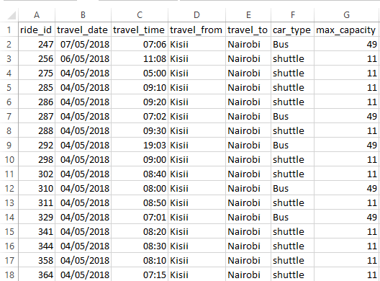
Figure 1.2
Observations
The training dataset (train_revised.csv), the variable ride_id appears multiple times in the dataset which is different from the testing dataset (test_question.csv).
The training dataset has more columns compared to the testing dataset.
In both dataset there is no variable which stores the total number of tickets sold for each ride from all routes. This build the question and defines what the model should do, predict the number of tickets for each ride.
Assumptions in creating the model
To get the number of tickets for each ride in the training dataset, we count/aggregate how many times the ride_id has been repeated in the dataset. To achieve this, we consolidate the ride by count of the ride_id and store them in a variable no_of_tickets. Then, merge the aggregate to the training dataset and remove the duplicates.
Name the new dataset as train_aggregate.csv, which has an addition variable which answers our question on number_of_tickets sold per ride. The new train dataset should now have the following variables; ride_id, travel_date, travel_time, travel_from, travel_to, car_type, max_capacity, number_of_tickets. The new dataset will be used to create a predictive model to predict the outcomes of the testing dataset.
Conclusions
From the problem description, to build a model to predict the number of seats that Mobitickets can expect to sell for each ride for a specific route on a specific date and time, the aggregated training dataset with already determined or known outcomes will be ideal training dataset to solve this problem.

Model using regression
Regression analysis – is a set of statistical processes for estimating the relationship among variables and understanding which among the independent variables are related to the dependent variables and explore the nature of the identified relationships.
Regression model – it’s used to investigate the relationship between two or more variables and use it to estimate one variable based on the others.
Solution
From the aggregated training dataset (train_aggregate.csv), identify the independent and dependent variables. The dependent variables in this case will be the number of tickets for each ride, this is because it’s dependent to the route on a specific date and time. This makes route as an independent variable.
The summary output between routes against the number of tickets
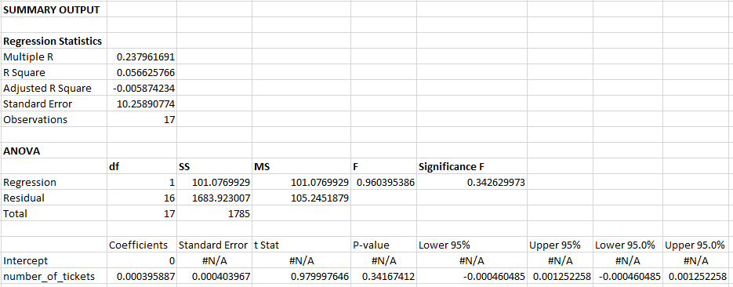

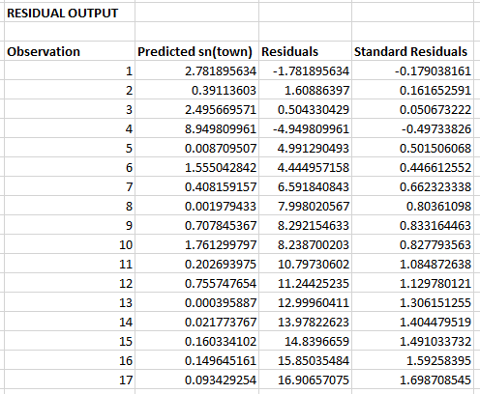 | 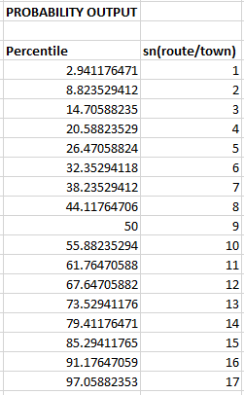

Model using R.
Coefficients:
(Intercept) number_of_tickets
10.3040303 -0.0004292

# A tibble: 6 x 9
town_from number_of_tickets .fitted .se.fit .resid .hat .sigma .cooksd .std.resid
<int> <int> <dbl> <dbl> <dbl> <dbl> <dbl> <dbl> <dbl>
1 1 7027 7.29 1.39 -6.29 0.0914 4.43 0.103 -1.43
2 2 988 9.88 1.20 -7.88 0.0674 4.24 0.114 -1.77
3 3 6304 7.60 1.31 -4.60 0.0807 4.59 0.0476 -1.04
4 4 22607 0.600 4.23 3.40 0.844 4.18 9.39 1.87
5 5 22 10.3 1.28 -5.29 0.0775 4.53 0.0602 -1.20
6 6 3928 8.62 1.13 -2.62 0.0604 4.71 0.0111 -0.587

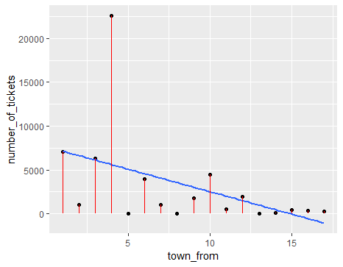

Create a model and show regression modelling assumptions
Linearity - The relationship between the predictor (x) and the outcome (y) is assumed to be linear. The linearity assumption can be checked by inspecting the Residuals vs. fitted plot (1st plot)
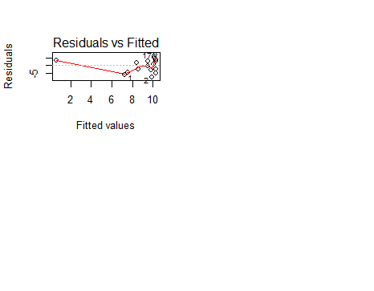
Normality of residuals. The residual errors are assumed to be normally distributed. Constant variance. The QQ plot of residuals can be used to visually check the normality assumption. The normal probability plot of residuals should approximately follow a straight line.
Homogeneity of residuals variance. The residuals are assumed to have a constant variance (homoscedasticity)
Independence of residuals error terms
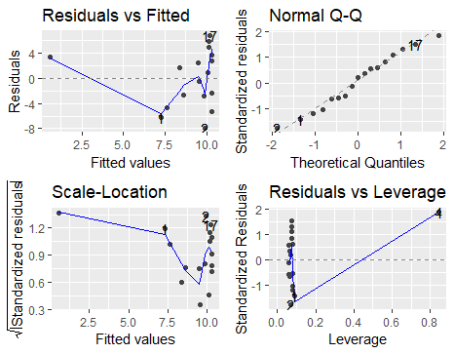

Conclusion
The model can be used to predict the number of tickets in the testing dataset

